**Steps to Execute the Code File**

1. **Download Everything and upload in your Google Drive**

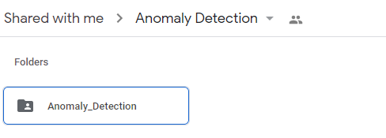

1. **Open Anomaly_Detection Folder and open with Collaboratory**

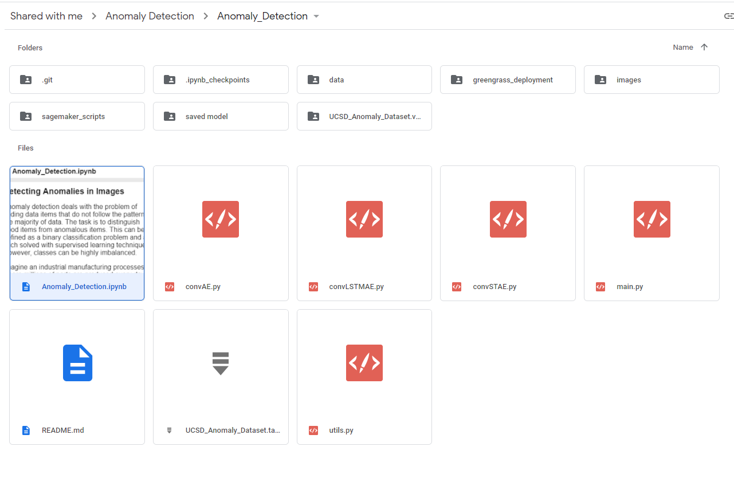

1. **Colab Notebook will be opened, connect it and change runtime from “None” to “GPU” and click save**

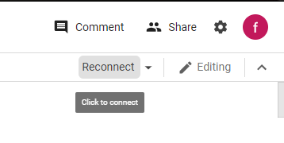 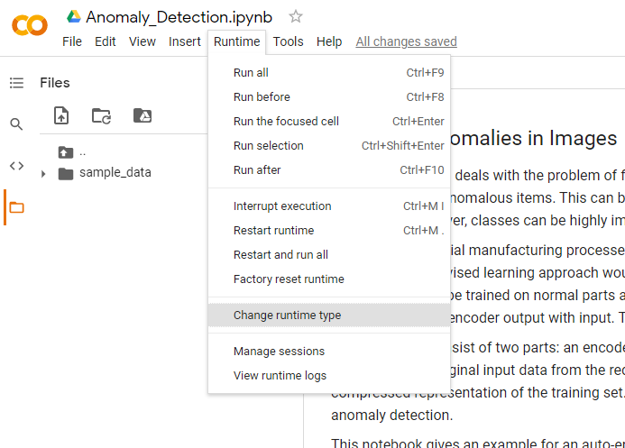

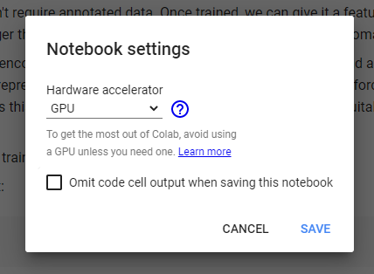

1. **Mount your Google Drive with Colab by executing following code snippet**

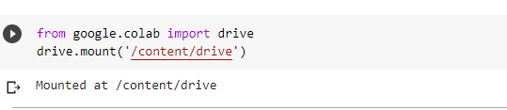

1. **Link your Google account with Colab by clicking on the below link in the blue. Select a google account you want to attach. Click allow and lastly a code will appear. Copy and paste the code back into the colab cell**

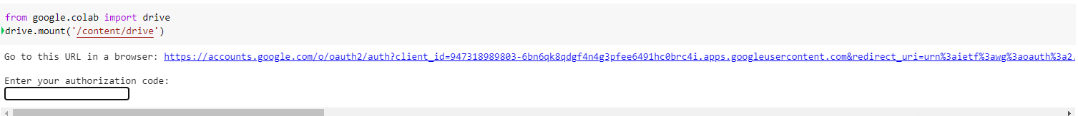

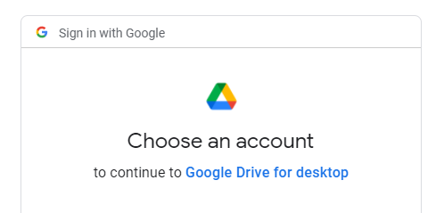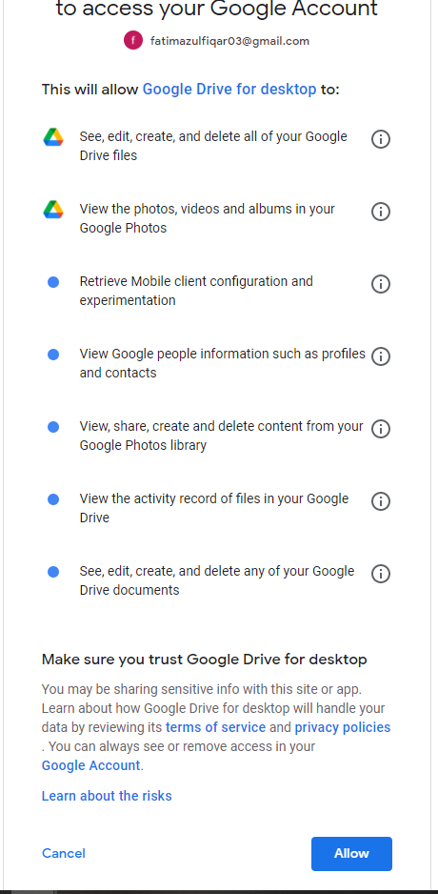

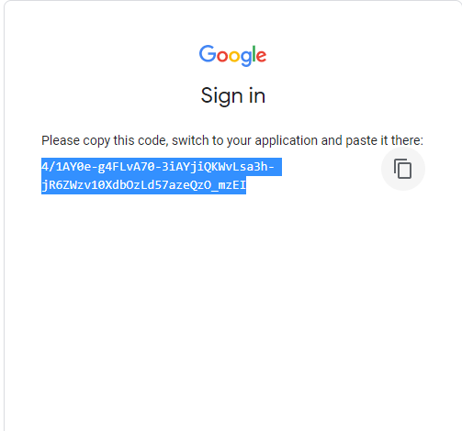

1. **Change your Colab directory by copying path where your code is present**

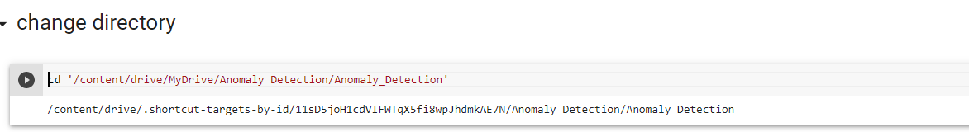

1. **Install Mxnet**

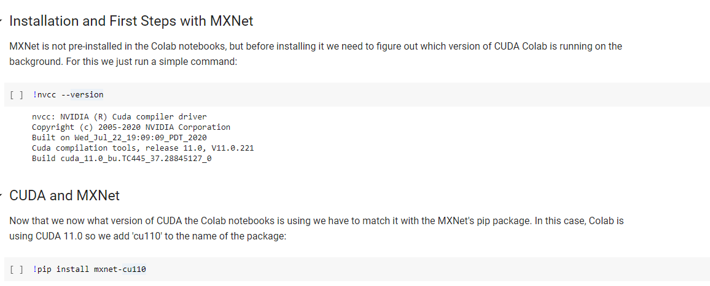

1. **Execute cells one by one for training and evaluation**